Marketing Promotion Kit – AllSTARTM

Congratulations and welcome to Orthomerica’s AllSTAR TeamTM! To help you share the news, we’ve put together some marketing promotional materials. We’ve created a press release template and sample social media posts along with general social media ideas and best practices. We also offer our direct help if you’d like further assistance.

Press Release Template
We crafted a ready-made draft of a press release. Simply update the yellow highlighted areas, remove the highlight, and you’re all set. We can help with these edits if you like. The completed document can be posted to your website under a news category or even your blog and then linked to in your social media.

Social Media
Use these as templates for your own social media posts. Remember, Twitter is more casual, Facebook is more personal, and LinkedIn is more professional. Instagram and TikTok are also popular platforms. Focus on whichever platform(s) you already use.

The link to your press release will generate a preview on social media. Having an image in your post is always important on social media. We suggest using a URL shortener like Bitly rather than the full URL.

Twitter – from your own (personal) account
Sample Post #1
Exciting news! I am now an AllSTAR! The AllSTAR Team is an exclusive global network of cranial clinicians. I’m committed to providing infants with the best patient care and results using proven best practices and solutions!

(@YourCompanyTwitterAccount) @Orthomerica #CranialHeadBand #Plagiocephaly #Craniosynostosis #YourCity (link to your press release)

Sample Post #2
I am now an AllSTAR! This program represents the largest global footprint of cranial specialists and enhances parents’ access to the highest quality clinical care programs like (your company name).

(@YourCompanyTwitterAccount) @Orthomerica #FlatHeadSyndrome #OandP #YourCity
(link to your press release)

Twitter – from your company’s account
Sample Post #1
Exciting news! (@YourOwnTwitterAccount or your name) is now an AllSTAR! The AllSTAR Team is an exclusive global network of cranial clinicians. We’re even more committed to providing infants with the best patient care and results using proven best practices and solutions!

@Orthomerica #CranialHeadBand #Plagiocephaly #Craniosynostosis #YourCity (link to your press release)

Sample Post #2
(.@YourOwnTwitterAccount or your name) is now an AllSTAR! This program represents the largest global footprint of cranial specialists and enhances parents’ access to the highest quality clinical care programs like (your company name).
@Orthomerica #FlatHeadSyndrome #OandP #YourCity (link to your press release)

LinkedIn – from your own (personal) account
Sample Post #1
Exciting news! I am now an AllSTAR! The AllSTAR Team is an exclusive global network of cranial clinicians. We’re even more committed to providing infants with the best patient care and results using proven best practices and solutions!

(@YourCompanyLinkedInAccount) @Orthomerica #CranialHeadBand #Plagiocephaly #Craniosynostosis #YourCity (link to your press release)

Sample Post #2
I am now an AllSTAR! This program represents the largest global footprint of cranial specialists and enhances parents’ access to the highest quality clinical care programs like (your company name).

(@YourCompanyLinkedInAccount) @Orthomerica #FlatHeadSyndrome #OandP #YourCity
(link to your press release)

LinkedIn – from your company’s account
Sample Post #1
Exciting news! (@YourOwnLinkedInAccount or your name) is now an AllSTAR! The AllSTAR Team is an exclusive global network of cranial clinicians. We’re even more committed to providing infants with the best patient care and results using proven best practices and solutions!

@Orthomerica #CranialHeadBand #Plagiocephaly #Craniosynostosis #YourCity (link to your press release)

Sample Post #2
(@YourOwnLinkedInAccount or your name) is now an AllSTAR! This program represents the largest global footprint of cranial specialists and enhances parents’ access to the highest quality clinical care programs like (your company name).
@Orthomerica #FlatHeadSyndrome #OandP #YourCity (link to your press release)

Facebook – from your company’s account
Sample Post #1
Exciting news! (@Your name) is now an AllSTAR! The AllSTAR Team is an exclusive global network of cranial clinicians. We’re even more committed to providing infants with the best patient care and results using proven best practices and solutions!

@Orthomerica #CranialHeadBand #Plagiocephaly #Craniosynostosis #YourCity (link to your press release)

Sample Post #2
Are you concerned about your baby's head shape? We understand, and we're here for you! (Company name) is an AllSTAR clinical program! We are committed to providing infants with the best patient care and results using proven best practices and solutions!

Schedule a FREE evaluation with us today, because every tiny head deserves the best attention and care. We’ll provide you with a comprehensive assessment of your baby's head shape, personalized treatment recommendations, and a detailed report to share with your pediatrician.
@orthomericaSTARband @orthomerica #STARband #plagiocephaly #tummytime

Instagram – either your own account or your company’s account or both
(use an image, ex., the AllSTAR logo and your image or logo)
Are you unsure about your baby’s head shape?

Call us at (123) 456-6789 to schedule a free thorough consultation.

We are now an AllSTAR Team member! We’re even more committed to providing infants with the best patient care and results using proven best practices and solutions!

@orthomerica @orthomericaSTARband #plagiocephaly #craniosynostosis #torticollis

Orthomerica Links
Home page: https://www.orthomerica.com/
STARband: https://www.orthomerica.com/product-category/starband/
Find a Local Provider: https://www.starbandkids.com/locations/

AllSTAR Logos and Images

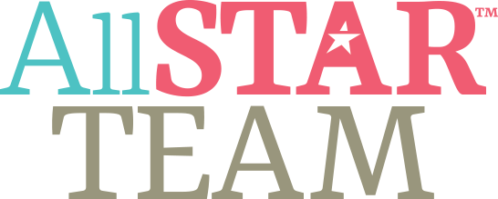

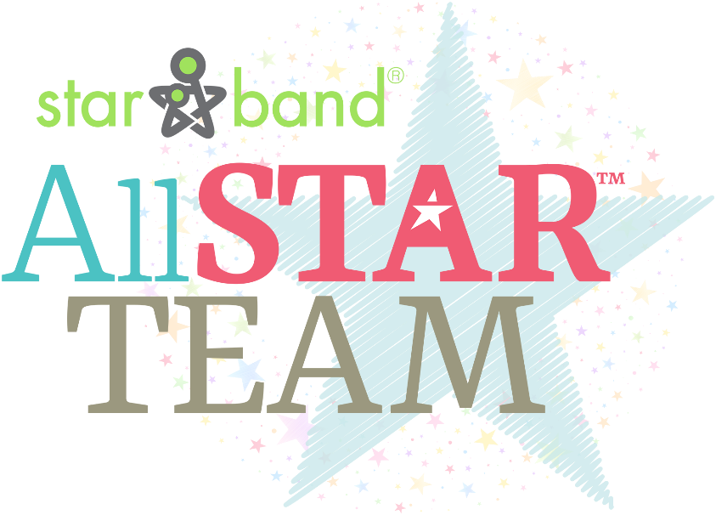

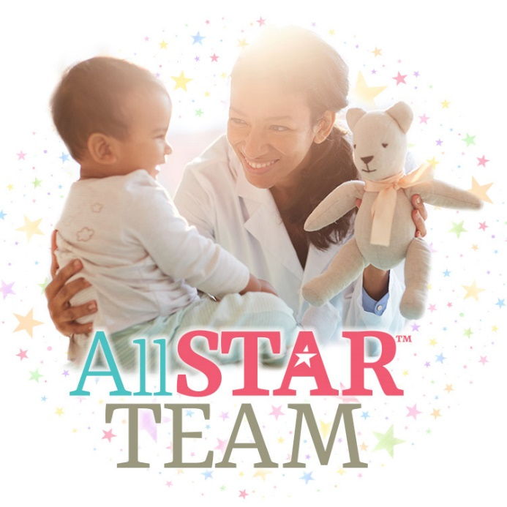



Orthomerica Logo
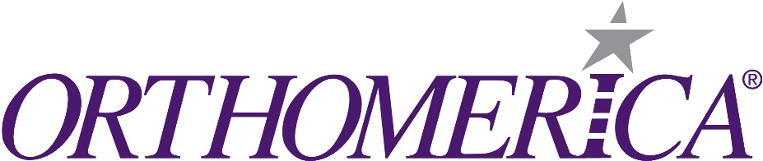

Orthomerica Contact:

Dan Alred
Marketing Communications Manager
dalred@orthomerica.com
FOR IMMEDIATE RELEASE

(Your name) at (Your Company Name) Joins the AllSTAR Team
(optional sub-headline) An International Network of Cranial Clinicians

(Insert your city, state, Date – ex. Orlando, FL, January 2, 2024) – (Your name) announced their membership to an exclusive global network of cranial clinicians. The Orthomerica AllSTARTM Team is comprised of a select group of exceptional clinicians who have developed proven expertise in cranial remolding treatment. They are the very best in this specialized area of pediatric care.
(Your name) at (your company name) is committed to providing infants with the best patient care and results using proven best practices and solutions. (Your name) is dedicated to the care of infants with deformational plagiocephaly and post-operative craniosynostosis using the STARband® Family of cranial remolding orthoses manufactured by Orthomerica.
(insert a quote from you about what being an AllSTAR means to you or how the STARband helps your company)
The AllSTARTM cranial network was developed to recognize and promote the clinical expertise of orthotic clinicians like (your name) who specialize in the management of infants with skull deformities. This program represents the largest global footprint of cranial specialists and enhances parents’ access to the highest quality clinical care programs like (your company name).
“Orthomerica works hard to support our cranial programs, cranial clinicians, and AllSTAR members,” said Christina Hinton, Cranial Products Manager at Orthomerica. “We are excited that (your name) has joined the AllSTAR Team!”
The AllSTAR network focuses on evidence-based medicine and membership is maintained through continuing education, the use of standardized clinical protocols, excellent patient care, and an ongoing professional dedication to this medical specialty.

About (your name):
Include a brief bio about you (try to keep it under five lines).

About (your company name):
Insert your company’s boilerplate About Us here, including a website link.

About Orthomerica Products, Inc.:
Orthomerica is a technology innovator and a leading designer and manufacturer of prefabricated, semi-custom, and custom orthoses (braces) – serving the orthotics and prosthetics (O&P) industry with superior customer service and quality. Additionally, Orthomerica is the world leader in the manufacturing of cranial remolding orthoses (CROs or cranial bands) used to treat infants with abnormal skull shapes. Founded in 1989, Orthomerica has over 90,000 square feet of manufacturing space in Orlando with over 240 employees. Website: www.orthomerica.com

Contact:
Your Name
Title
Phone
E-mail

(Company name) Contact:
Name
Title
Phone
E-mail

Orthomerica Contact:
Dan Alred
Marketing Communications Manager
407-290-6592, ext. 1259
dalred@orthomerica.com

###

